# ACTIVITY: WORKING AT BANDHARA PUMPING STATION _____________________________________________________________________

* Objective : - Safe and quality maintenance of pump for optimum output
* Scope : - All new working pumping stations
* Ref. : - Pumps maintenance manual
* Responsibility : - Engineer In charge & Maintenance Fitter on job

**PPE –s to be used :**

• safety Helmet, Safety shoes, hand gloves, safety goggle, life buoy and jacket

|  |  |  |
| --- | --- | --- |
| Work No 1 | : | Changing of pump |
| Work No-2 | : | Dismantling of bowl assembly of vertical turbine pump |
| Work no-3      **Aspect - Impact** | : | Inspection and replacement |
| Scrap generation |  | Resource Depletion |
| Oil Spillage |  | Land contamination |

Oil traced waste generation Land contamination & Resource Depletion

Fumes Health

Draining of water Resource depletion

# Hazards identified

Mechanical hazard -

* Trapping in between coupling, impeller, guard, dismantled pump and motor, etc.
* Entanglement in between moving parts, guard, coupling.
* Fall of spare parts, rod, slinged items, tools, hammer, etc.
* Fall of person from platform & height.
* Impact of moving/slinged items.
* Injury from slip of pump component while assembly / dismantling.
* Impingement of fingers, hand while fitting assembly of pump, bearing fixing, impeller fixing

Physical hazard;

- Pressure, congestion

Drowning in water inside jack well, river water

Lack of oxygen while working inside jack well tank

Chemical

- Fire

Electrical

- Shock due to welding machine, electrical cable

Electrical hazard due to water spillage on overhead conductor from surge tank.

**Biological Hazard**

- Bee sting

**Human Behavior aspect of operators**:

Operator nature, alcoholism, casual approach, horse play, use of mobile at workplace, back pain & non usage of PPE?s

Workmen carrying out the jobs at Bandhara pump house/new pump pits must know swimming and must equip with life buoy. The well is a confined space and going inside well is restricted. The person who goes inside the well should know swimming, and ensure the water level in the river is in low tide and gate valves are closed (this is a closed supervision job).

Ensure that the cover plate to go inside the well is locked every time (other than non-routine inspection/ activity inside the well)

Type of pump used : Vertical turbine pump

A vertical line shaft turbine pump consists of five basic components. These components are the pump bowl assembly, column pipe, line shafting, discharge head and the driver.

# Work No 1 : Changing of pump

1. Take clearance from production.
2. Take electrical shutdown LOTO, before starting the activities.
3. Remove coupling guards and coupling.
4. To remove motor/pump makes use of the 3T EOT hoist provided inside pump house.
5. EOT should be approved by competent authority.
6. Replace the pump and check alignment. Follow work instruction WI/MAINT/12 for material handling.
7. Check oil level in bearing block and top up if required.
8. Close discharge valve and depressurize the casing by opening vent valve / plug in casing
9. Remove coupling guard and de-couple to isolate pump from the motor.
10. Drain the oil in oil can with care. Remove oil cup with care to avoid breakage in handling. Applicable to pumps with lubricating oils.
11. Open the casing bolts with correct size spanner. Keep two bolts loose.
12. Sling the pump assembly with the hoist provided overhead. Use 3T/5T sling.
13. Remove pump assembly from casing by tightening jack bolts. Due care to be taken to avoid fall of pump assembly on legs or entanglement.
14. If impeller is to be replaced, remove the impeller nut and fix new impeller. The Impeller should be tight on shaft and lock nut/sleeve should be fixed tight with washer / gasket.
15. If bearings are damaged then, replace the bearings (no need to remove the entire pump assembly).
16. Pump assembly has to be shifted as per material handling procedure to site.
17. Inspect the casing wear ring for wear and replace it with new one.
18. Sling the pump assembly and insert inside casing. Fix bolts and uniformly tighten. .
19. Couple the pump with motor and fix guard.
20. Fill oil after fixing plug and oil gauge.
21. Do handle oil with utmost care to avoid the spillage. Use the lubricant recommended as per maintenance manual and as per procedure VL/IMS/PID1/MECH/WI/92
22. Open discharge valve of pump to check leakage.
23. Clear electrical shutdown and take trial of pump in co-ordination with electrical & operation person.
24. Measure vibration, current, pressure, & check for any gland leakage, casing leakage, etc.
25. If found within acceptable limits, give clearance to production department.

# Work No-2 Disassembly of bowl assembly of vertical turbine pump

1. The bowl assembly should be disassembled in a clear area.
2. Place the bowl assembly in a horizontal position with a support under the first bowl above the suction case.
3. Measure and record the projection and axial play of the shaft.
4. Remove the suction case plug.
5. Remove the cap screw from suction case flange.
6. Slide suction case off the pump shaft.
7. Loosen set screws in suction case and slide sand collar off end of pump shaft.
8. Use collect driver to drive impeller collect toward discharge case of bowl assembly.
9. Slide impeller off pump shaft.
10. Spread spilt collect with the screwdriver and slide collect off pump shaft.
11. Remove cap screws from the pump bowl. Move support to under next bowl. Slide the pump bowl off pump shaft.
12. Repeat steps 7 through 10 to remove remainder of bowls including the top bowl.
13. Slide the discharge case off the pump shaft.

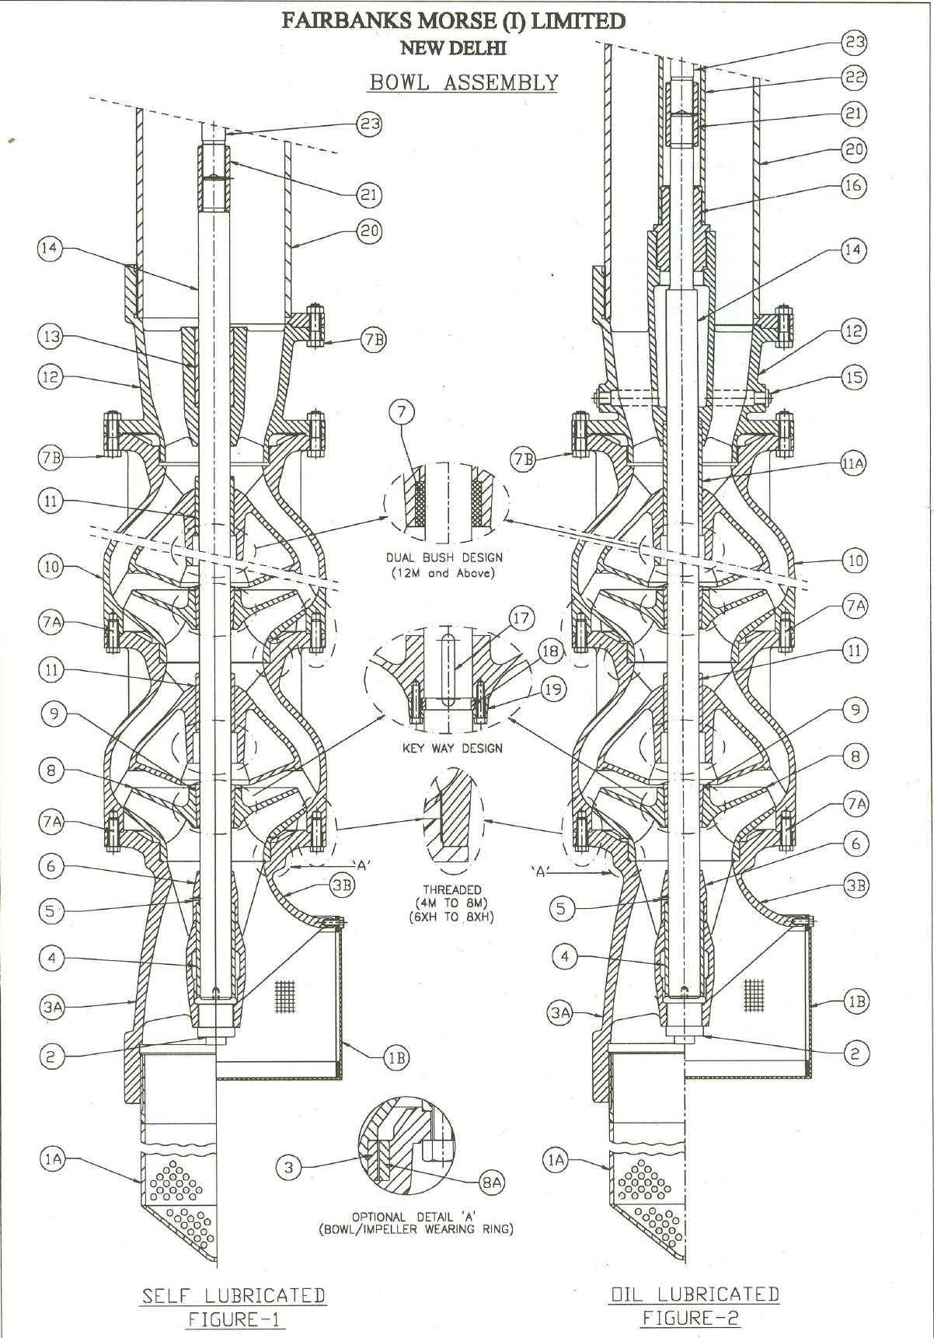

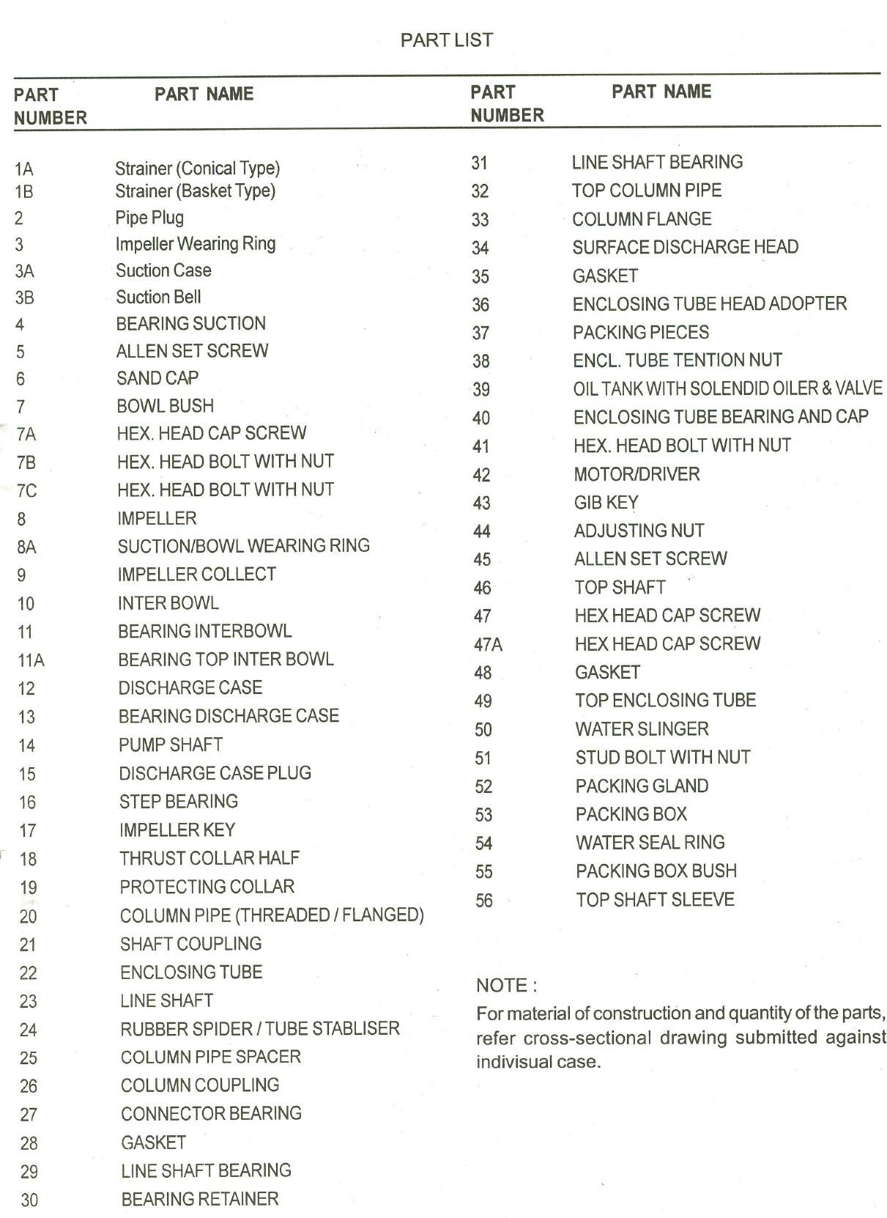

# Work no-3 Inspection and replacement

1. After the components are disassembled, each part should be thoroughly cleaned and inspected for wear and physical damage.
2. Any part showing signs of excessive wear or damage should be replaced with genuine spare parts supplied.

**Please note: -**

* **TO AVOID BENDING OR DAMAGING, DO NOT PICK UP BOWL ASSEMBLY BY THE SHAFT**.
* **While working in the vicinity of surge tank, a work permit has to be taken from Electrical department since the 11KV substation is very close to the surge tank area. The work will be carried out under the strict supervisions of VL staff. While issuing the work permit it is necessary that we put off 11KV supply from GED mains.**
* **SP-44 “Procedure to work in the vicinity of over head electric line” shall be followed strictly.**

**Amendement Record**

|  |  |  |  |
| --- | --- | --- | --- |
| **Date** | **Manual Section Ref. & Para** | **Brief details of Revision** | **New Rev.** |
|  |  |  |  |
|  |  |  |  |
|  |  |  |  |

|  |  |  |
| --- | --- | --- |
| **Prepared By:**  Area Engineer | **Reviewed & Issued By:**  Management Representative | **Approved By:**  Mechanical Head |
| **Signature** | **Signature:** | **Signature:** |
| **Review Date: 12.12.22** | **Review Date: 12.12.22** | **Review Date: 12.12.22** |